ISTQB certification roadmap
# Source: Chatgpt (GPT-5-Standard) at [8/14/2025]
Here’s the ISTQB certification roadmap after Foundation Level (FL) — structured from beginner to expert:

1. Foundation Level (FL)
# Source: Chatgpt (GPT-5-Standard) at [8/14/2025]
- Purpose: Entry-level, covering testing basics.
- Variants:
  - Core Foundation Level – General testing concepts.
  - Foundation Level Agile Tester (FL-AT) – Basics of testing in Agile environments.
  - Foundation Level Mobile Application Testing (FL-MAT) – Testing mobile-specific features.
  - Foundation Level Automotive Software Tester (FL-AuT) – For automotive industry software.
  - Foundation Level Model-Based Tester (FL-MBT) – Using models to design and execute tests.
  - Foundation Level Performance Testing (FL-PT) – Performance, load, and stress testing basics.
  - Foundation Level Security Tester (FL-SEC) – Basics of security testing.

2. Advanced Level (AL)
# Source: Chatgpt (GPT-5-Standard) at [8/14/2025]
- Purpose: For experienced testers, test analysts, and managers.
- Core Advanced Certifications:
  - Advanced Level Test Manager (AL-TM) – Test planning, estimation, team leadership.
  - Advanced Level Test Analyst (AL-TA) – Designing functional tests.
  - Advanced Level Technical Test Analyst (AL-TTA) – Non-functional testing, white-box techniques.
- Specialist Advanced Certifications:
  - Advanced Level Security Tester (AL-SEC)
  - Advanced Level Test Automation Engineer (AL-TAE)
  - Advanced Level Test Process Improver (AL-TPI)

3. Expert Level (EL)
# Source: Chatgpt (GPT-5-Standard) at [8/14/2025]
- Purpose: Highest ISTQB level — for senior professionals and leaders.
- Modules:
  - Improving the Test Process
  - Test Management
  - Test Automation
  - Security Testing (expert level in development)

Roadmap Flow
# Source: Chatgpt (GPT-5-Standard) at [8/14/2025]
- Start: Foundation Level → optional specialized Foundation modules (Agile, Mobile, etc.)
- Next: Advanced Level (choose role-specific path: Test Manager, Test Analyst, Technical Test Analyst)
- Top: Expert Level (focus on leadership, process improvement, automation mastery)

Visual Hierarchy
# Source: Chatgpt (GPT-5-Standard) at [8/14/2025]
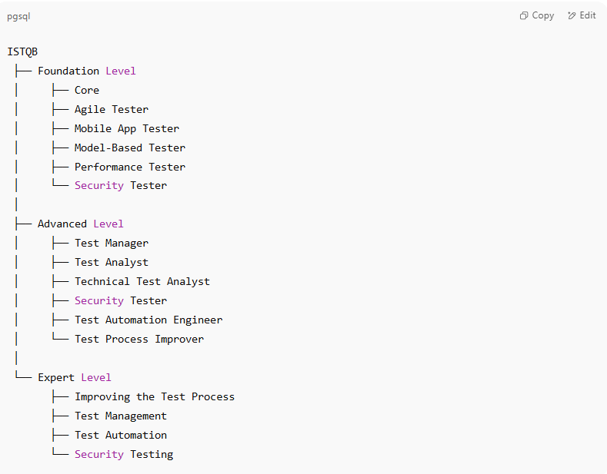
ISTQB
├── Foundation Level
│ ├── Core
│ ├── Agile Tester
│ ├── Mobile App Tester
│ ├── Model-Based Tester
│ ├── Performance Tester
│ └── Security Tester
│
├── Advanced Level
│ ├── Test Manager
│ ├── Test Analyst
│ ├── Technical Test Analyst
│ ├── Security Tester
│ ├── Test Automation Engineer
│ └── Test Process Improver
│
└── Expert Level
├── Improving the Test Process
├── Test Management
├── Test Automation
└── Security Testing

